Viscosity project summary_Section 2_ML

817cP

Table of content

**Standard 817 cP 2**

Set: 1 (amended - real LIN) 2

Set: 1 (absolute) 8

# Standard 817 cP

Machine learning segment

## Set: 1 (amended - real LIN)

Observation of trends

Observation 1: LIN scaling - divide

Quite a lot of repetition is seen for this set of trials. The test trials are decently accurate which falls within the preferred boundary of -2 to 2%. However, the transfer time is slightly higher than the average derived in standard calibration.

Observation 2: LIN scaling - multiply

There are a few sets of trials that have very long transfer times and the error also ranges from -10 to 2%. Even though it did come across very good parameters, it continued to explore. However, for iteration 3 to 6, one can see efforts of the system trying to fine tune a “favourable” set of parameters.

Observation 3: LIN scaling - none

The sets of parameters suggested are very random, however, the percentage error is maintained between -2 to -3%. There is a combination of very high and very low transfer times (transfer time ranges from 200 to 300s), even though the system did generate a favourable set of parameters, it continued to “explore” new parameters.

Error against iteration diagrams:

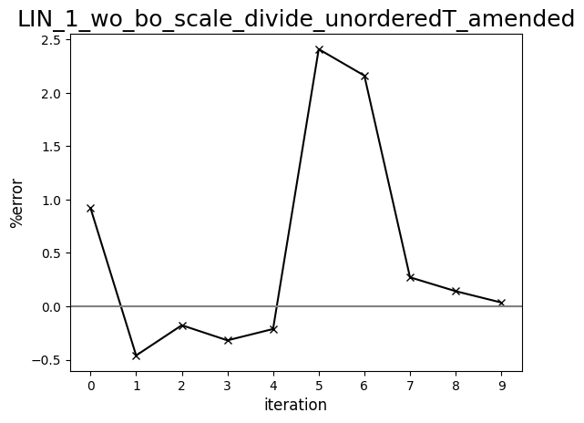

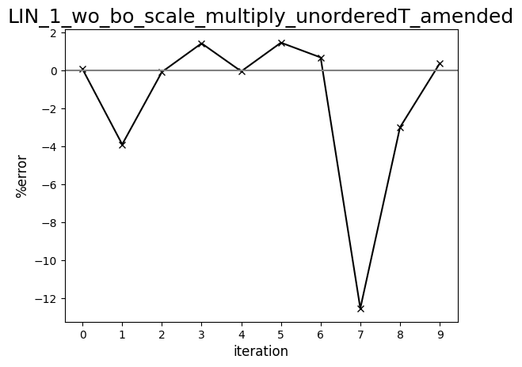

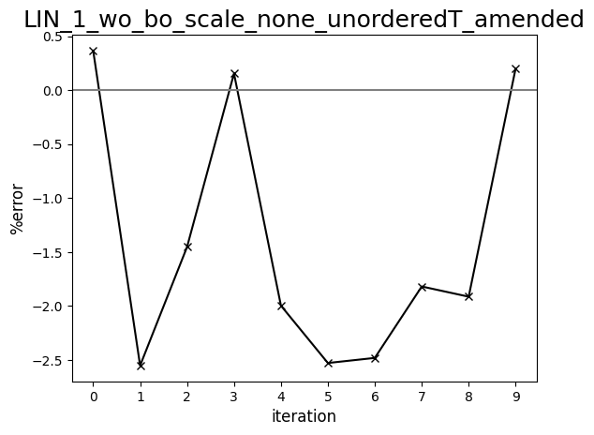

Diagram comparing human-driven and ML test trials (817 cP, set:1, amended - LIN)

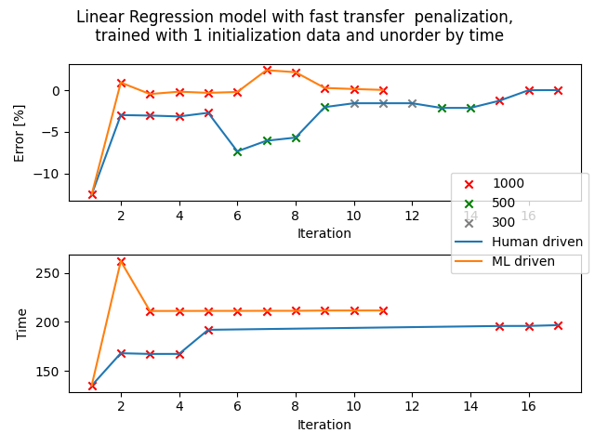

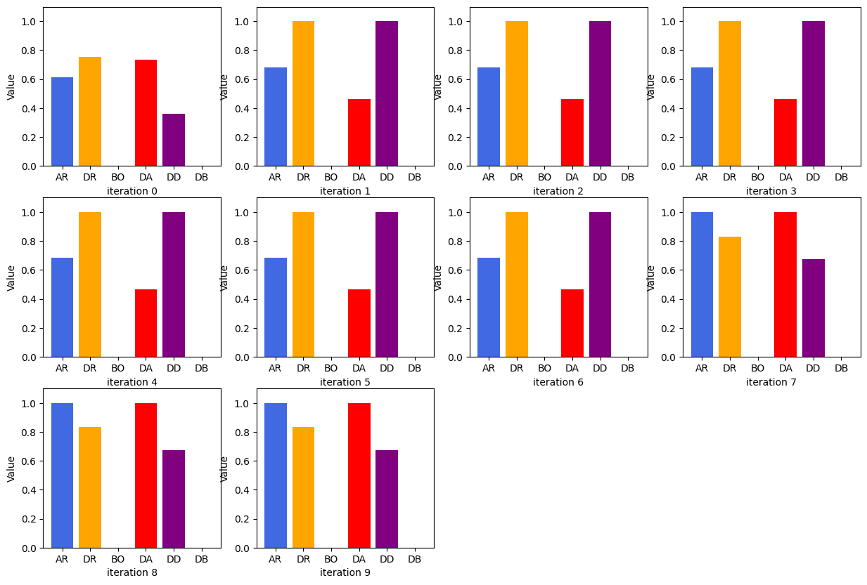

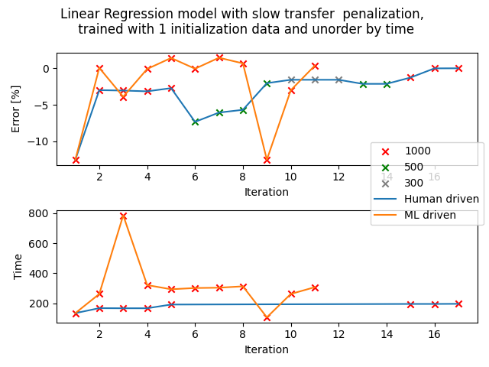

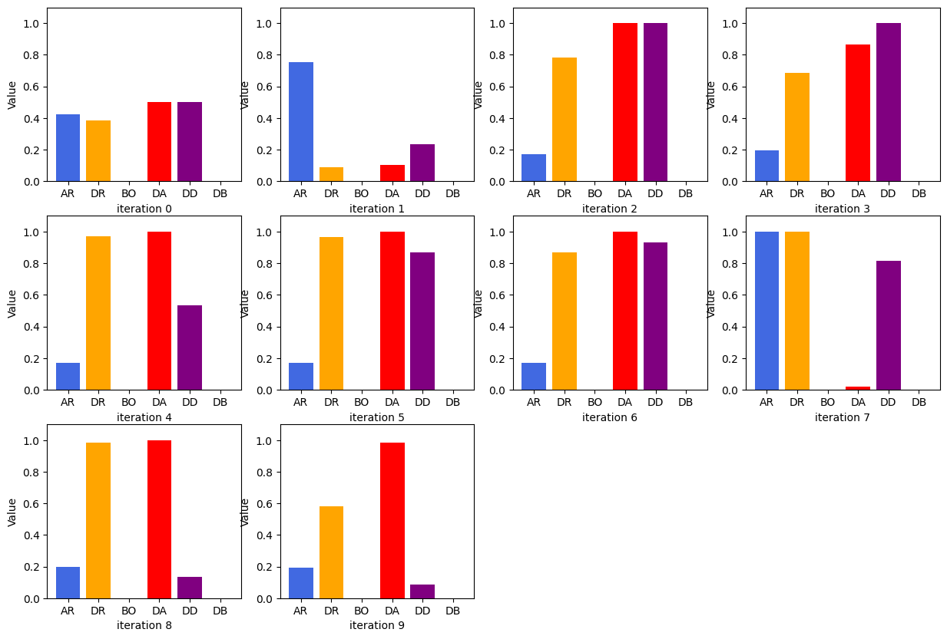

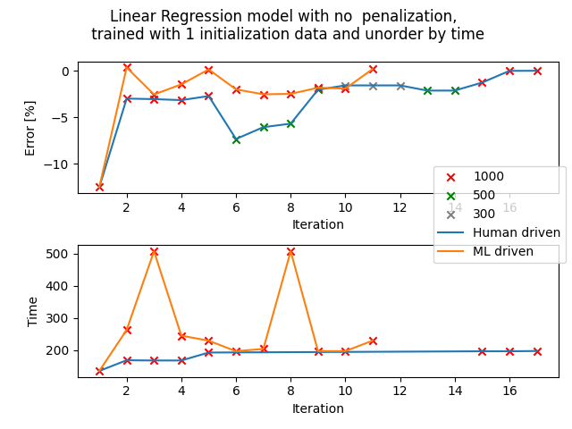

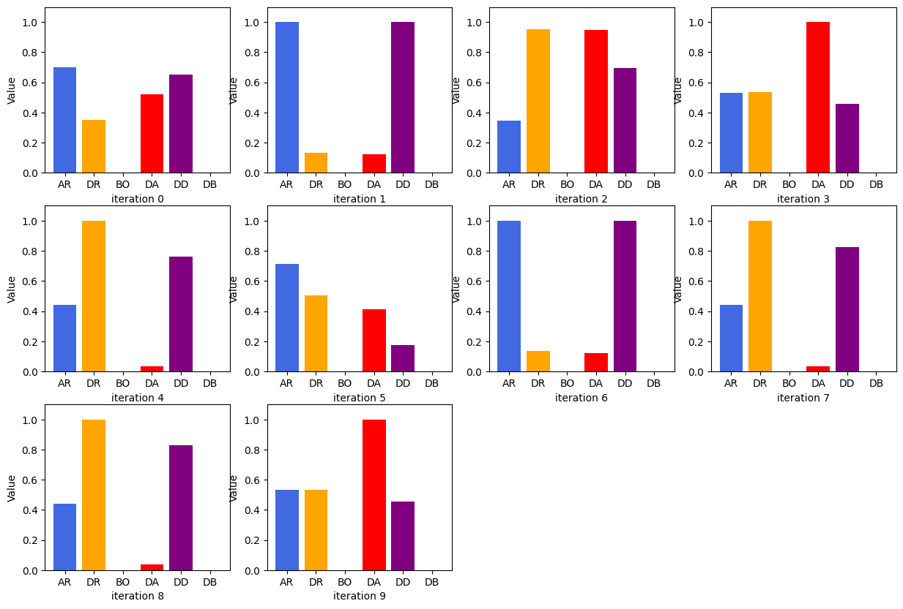

## Set: 1 (absolute)

Observation of trends

**Observation 1: GPR - scaling: multiply**

For most of the test trials, the percentage error falls beyond the preferred boundary of -2 to 2%, at around -3%, but the average transfer time is much faster than the one derived in standard calibration (40s difference). Thus, in this case, the slow time penalization seemed to work. Most of the trials are repetitions but it's alright since both the time and percentage error is more or less favourable.

**Observation 2: GPR - scaling: none**

Highly repetitive sets of parameters generated. Even though the transfer time is favourable - faster than standard calibration, the percentage error is between -3 to -4% for all the test trials.

Error against iteration graphs:

​​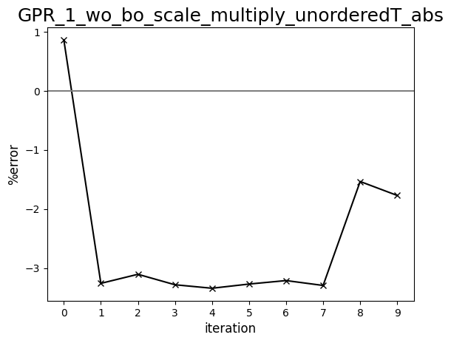

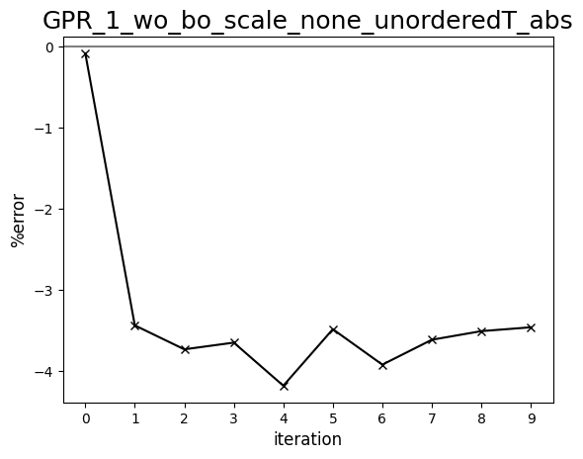

Diagram comparing human-driven and ML test trials (817 cP, set:1, absolute)

